**Scientific Computing and Data Management (SCDM)**

**Assignment: P2- Plotting oceanography data and times series**

**Robyn Daniels DNLROB007**

**Figure 1.** Line graph indicating the Temperature (Degrees Celsius) and Salinity (psu) profiles with depth (m) in blue and red respectively from a CTD measurement on the 11/29/2008.

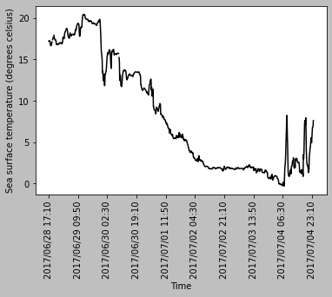

**Figure 2.** Timeseries indicating the sea surface temperature (degrees Celsius) from 28 June 2017 to the 04 July 2017 from data collected on SA Agulhas II winter cruise in the Southern Ocean.

**Figure 3.** Histogram showing the number of observations within the salinity (psu) ranges indicated from 28 June 2017 to the 04 July 2017 from data collected on SA Agulhas II winter cruise in the Southern Ocean.

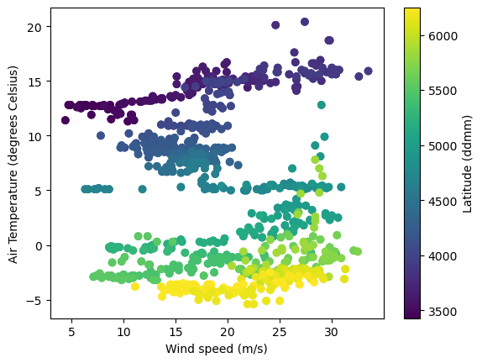

**Figure 4.** Scatterplot indicating the air temperature (degrees Celsius) and Wind speed (m/s) encoded with Latitude (ddmm) from 28 June 2017 to the 04 July 2017 from data collected on SA Agulhas II winter cruise in the Southern Ocean.